EXPT NO: 7 | GENERATE SYNTHETIC IMAGES USING A GENERATIVE ADVERSARIAL NETWORK (GAN)
DATE: 9.10.26

PRE-LAB QUESTIONS

1. What is a Generative Adversarial Network (GAN)?
A Generative Adversarial Network (GAN) is a deep learning model that generates synthetic data similar to real data using two neural networks called the Generator and Discriminator.

2. What are the roles of the Generator and Discriminator in a GAN?
The Generator creates synthetic images from random noise, while the Discriminator distinguishes between real images and generated images.

3. Why are GANs used for synthetic image generation?
GANs are used to generate realistic synthetic images, augment training datasets, and create new images similar to the original dataset.

4. What is the difference between real images and synthetic images?
Real images are captured or collected from actual sources, whereas synthetic images are artificially generated by computer models such as GANs.

5. Explain the concept of adversarial training in GANs.
Adversarial training is the process in which the Generator tries to create realistic images while the Discriminator tries to identify fake images. Both networks improve through competition during training.

AIM
To implement a Generative Adversarial Network (GAN) for generating synthetic images by training a Generator and Discriminator on an image dataset and evaluating the quality of the generated images.

SOFTWARE REQUIREMENTS
- Python
- TensorFlow / Keras
- Google Colab
- GitHub
- NumPy
- Matplotlib
- Pandas

OBJECTIVES
Students will be able to:
- Understand the architecture and working of Generative Adversarial Networks.
- Understand the roles of the Generator and Discriminator.
- Prepare and preprocess an image dataset for GAN training.
- Build a Generator network for synthetic image generation.
- Build a Discriminator network for distinguishing real and generated images.
- Train a GAN using adversarial learning.
- Generate synthetic images using the trained Generator.
- Visualize and analyze the quality of generated images.

PROCEDURE
PART A: DATASET PREPARATION AND IMAGE PREPROCESSING
Perform the following tasks:
- Load an image dataset such as the MNIST handwritten digit dataset.
- Explore the dataset and examine sample images.
- Check the number of images and image dimensions.
- Display sample images from the dataset.
- Normalize the pixel values to the range [-1, 1].
- Reshape the images into the required input format.
- Prepare the dataset for batch-wise training.
- Create a data pipeline using appropriate TensorFlow/Keras utilities.
CODE:
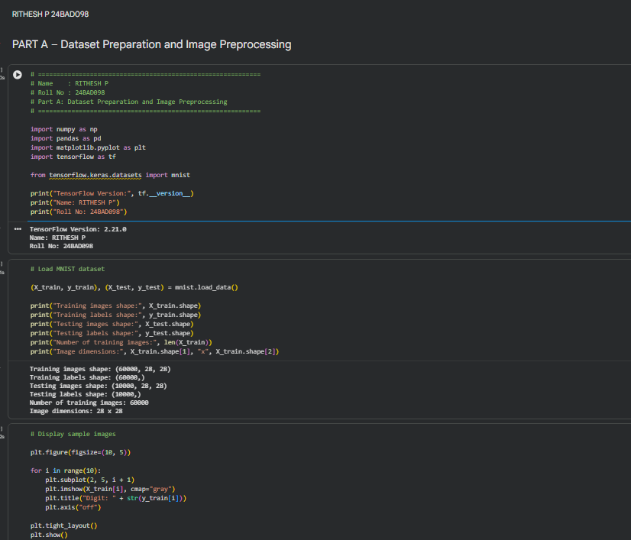
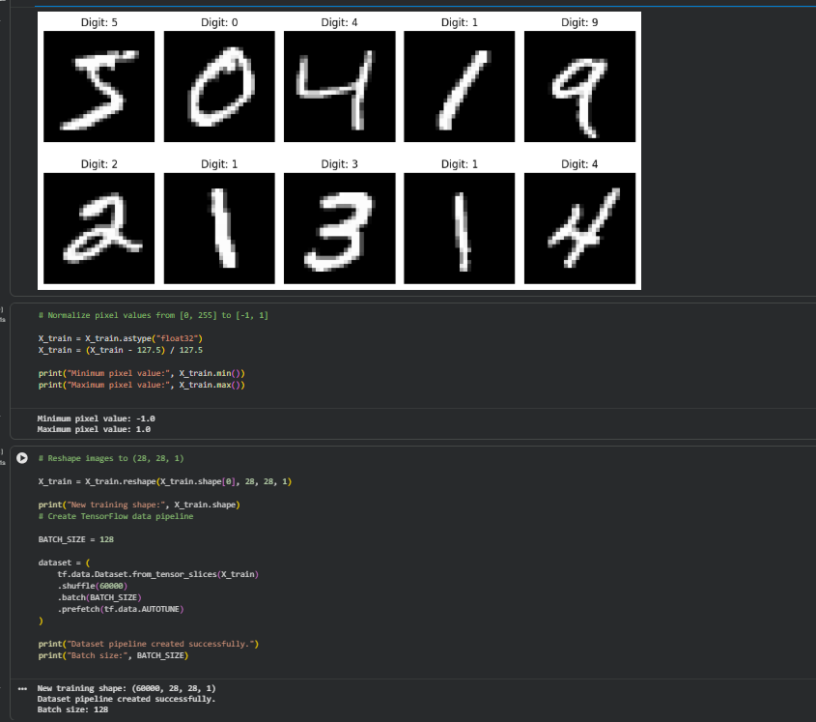

PART B: IMPLEMENTING THE GENERATOR
Perform the following tasks:
- Define a random noise vector as the input to the Generator.
- Create the Generator using appropriate neural network layers.
- Use Dense and convolutional/transposed convolutional layers to generate images.
- Apply appropriate activation functions.
- Generate an image from a random noise vector.
- Display the generated image before GAN training.
- Display the Generator model architecture and summary.
CODE:
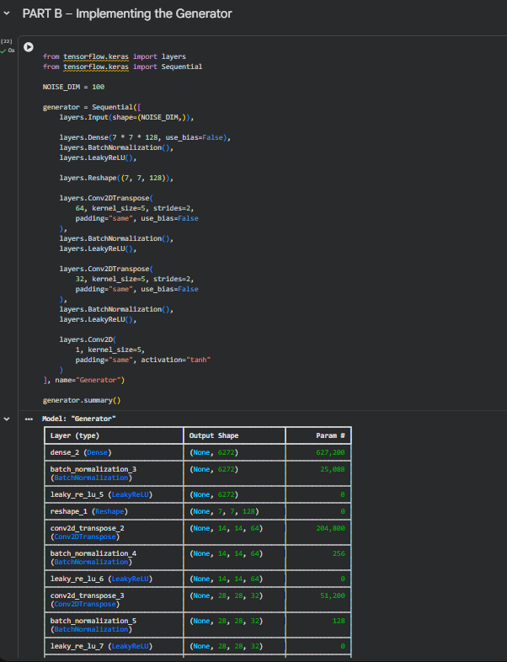
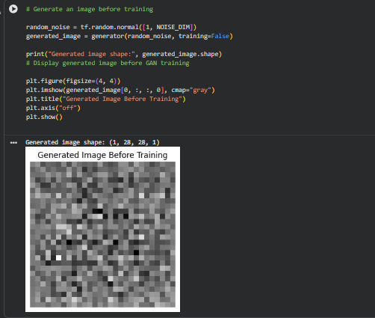

PART C: IMPLEMENTING THE DISCRIMINATOR AND GAN MODEL
Perform the following tasks:
- Create a Discriminator network to classify images as real or generated.
- Add convolutional layers to extract image features.
- Add appropriate activation functions.
- Add a final output layer for binary classification.
- Compile the Discriminator using:
  - Appropriate optimizer
  - Binary cross-entropy loss
- Combine the Generator and Discriminator to form the GAN.
- Display the Generator and Discriminator model summaries.
CODE:
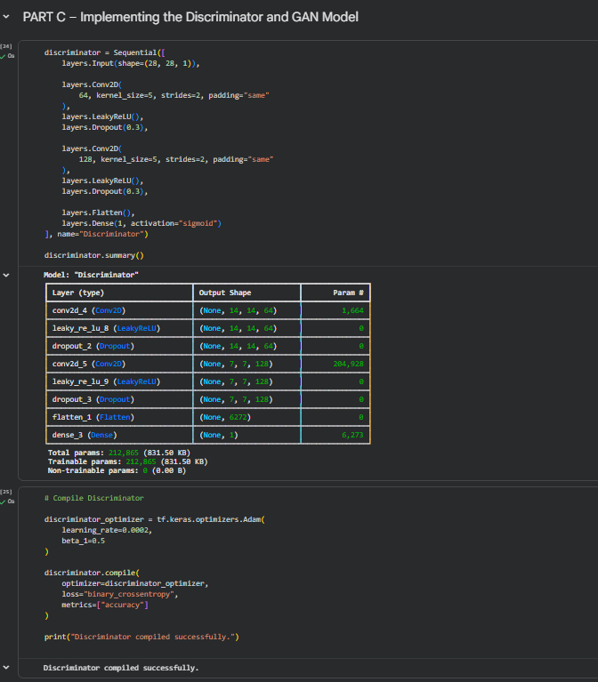
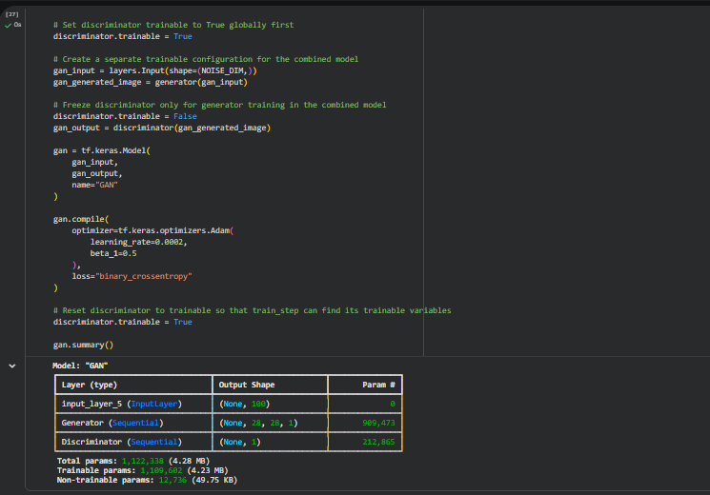

PART D: GAN TRAINING AND SYNTHETIC IMAGE GENERATION
Perform the following tasks:
- Initialize the Generator with random noise.
- Train the Discriminator using:
  - Real images from the dataset.
  - Synthetic images generated by the Generator.
- Train the Generator through the combined GAN model.
- Record:
  - Generator loss
  - Discriminator loss
- Repeat the training process for the specified number of epochs.
- Generate synthetic images at regular training intervals.
- Visualize generated images at different stages of training.
- Compare the generated images with real images.
- Analyze the quality and diversity of the generated images.
- Save the final generated images.
CODE:
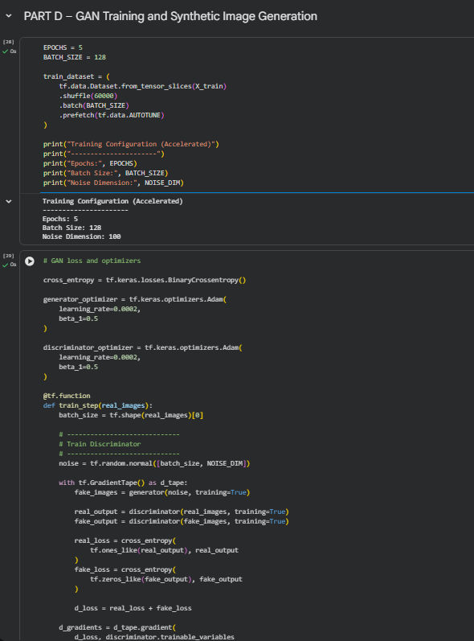
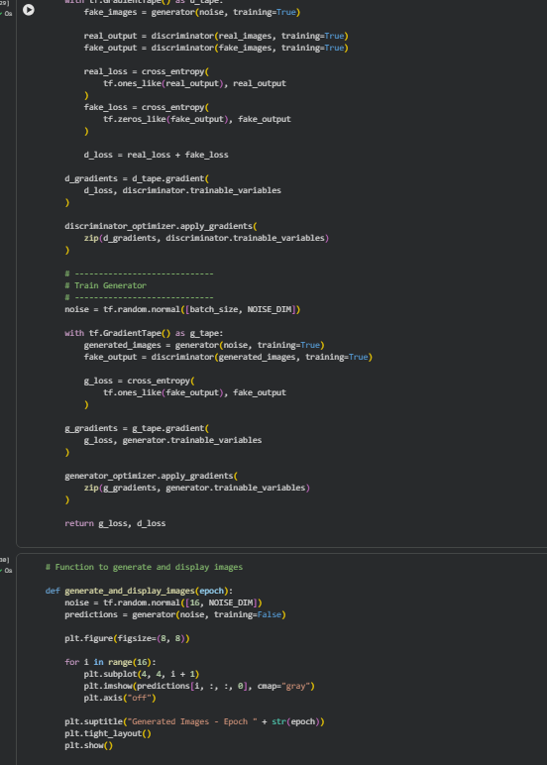
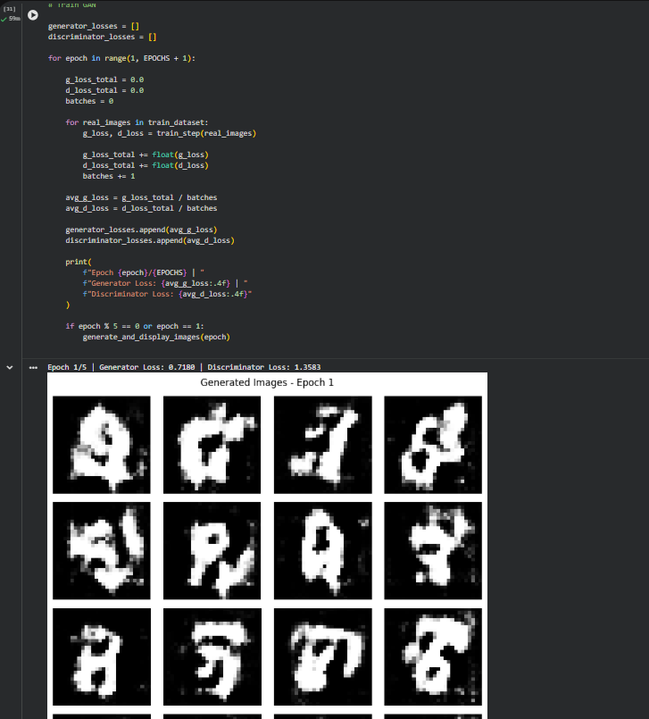
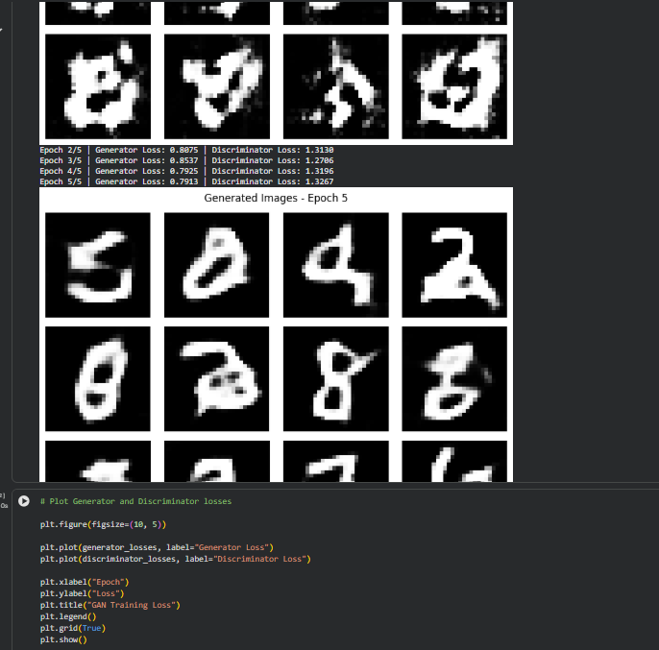
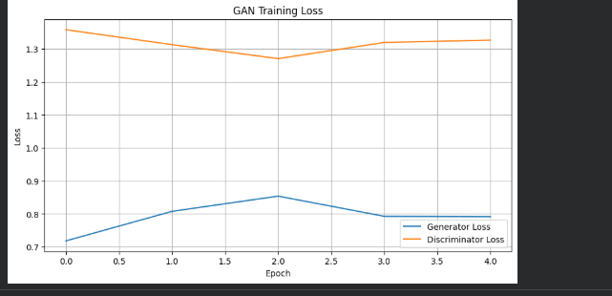
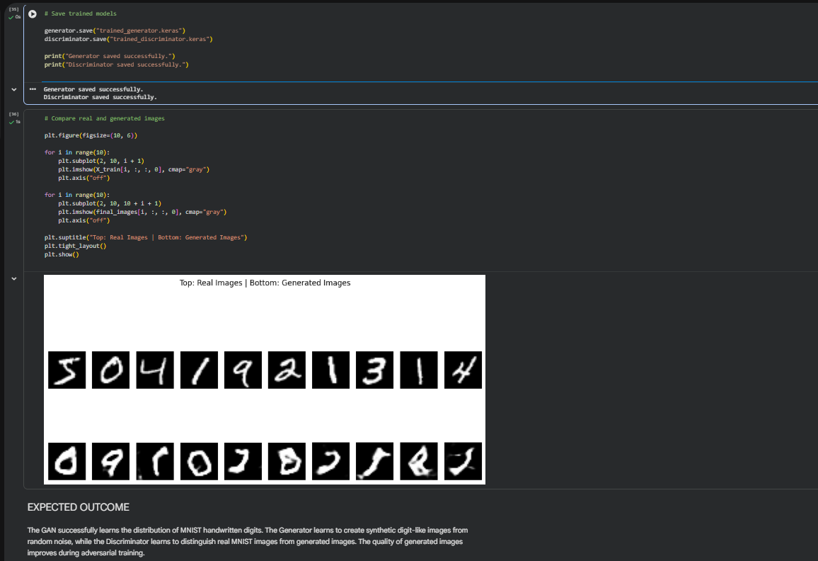

EXPECTED OUTCOME
Students will understand the architecture and working of Generative Adversarial Networks (GANs) and the interaction between the Generator and Discriminator during adversarial training. Students will learn to preprocess image data, build and train GAN models, and generate synthetic images. They will evaluate the generated images by visually comparing them with real images and analyzing the improvement in image quality during training.

POST-LAB QUESTIONS

1. What is the role of the Generator in a GAN?
The Generator converts random noise into synthetic images that resemble real images in the training dataset.

2. What is the role of the Discriminator in a GAN?
The Discriminator classifies input images as real or fake and provides feedback that helps the Generator improve.

3. Why is random noise used as input to the Generator?
Random noise provides different input values that allow the Generator to create diverse synthetic images.

4. What happens when the Discriminator becomes too strong during GAN training?
When the Discriminator becomes too strong, it easily identifies generated images as fake, making it difficult for the Generator to receive useful feedback and improve.

5. What is meant by mode collapse in GANs?
Mode collapse is a problem in which the Generator produces only a limited variety of images instead of generating diverse outputs.

6. How does the Generator improve the quality of generated images during training?
The Generator improves by learning from the feedback provided by the Discriminator and updating its weights through backpropagation to produce more realistic images.

7. Mention one real-world application of GANs.
GANs are used in image synthesis, such as generating realistic human faces and creating artificial training images for machine learning models.

8. What is the difference between GAN training and conventional neural network training?
GAN training involves two competing networks, the Generator and Discriminator, whereas conventional neural network training generally optimizes a single network using a defined loss function and target outputs.

ASSESSMENT
Description | Max Marks | Marks Awarded
Pre Lab Exercise | 5
In Lab Exercise | 10
Post Lab Exercise | 5
Viva | 10
Total | 30
Faculty Signature

